
Starter Kit Remote Plug-in Adaptor
PD3-2300

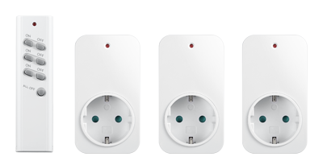

Specification:

Function: Remote: 3 Channel / All Off button

Plug-in adaptor: 2300W ON/OFF

Frequency: 433.92MHz

Power Rating: 230V~ 50Hz

2300W Resistive load

Battery: 3V CR2032 Lithium Cell Battery

Overview:

Starter kit for controlling your lights or electrical device. Each plug-in adaptor can store up to 3 memories.
3 set of ON/OFF button and additional ‘All Off’ button.

Paring:
Pairing using LEARNING MODE:
- Plug adaptor into a socket (LED will flash), this will now enter learning mode.
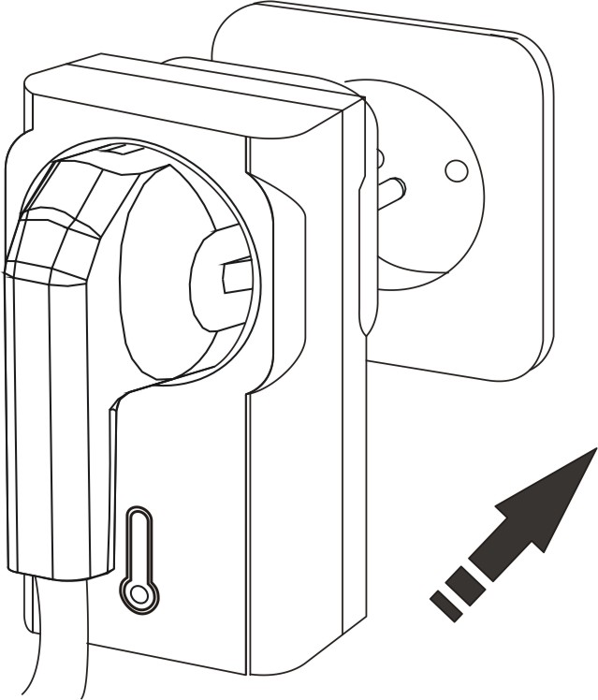
- Within the 5 seconds, with the remote control press the ‘ON’ button intended to be paired; the load will flash twice to confirm that the remote control is now paired.
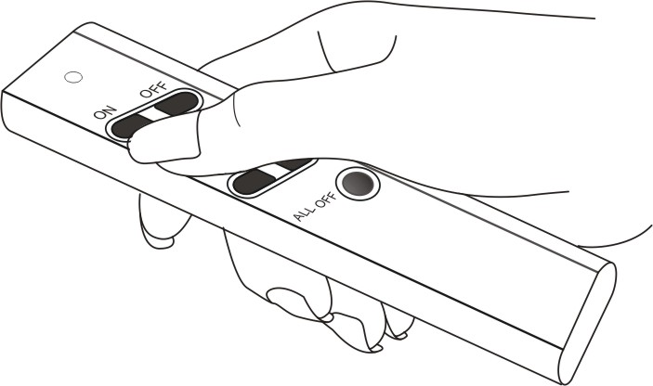
NOTE: Learning mode lasts for 10 seconds; if no signal is given to the receiver then it will automatically exit learning mode without pairing the device.
！If, during learning mode the load does not flash to confirm, this means that the receiver’s memory is FULL and no further remote control may be paired unless one of the existing remote control is first unpaired (see below).

Unparing:
Removing single device:
- Pull out the adaptor from socket, after 5 seconds plug adaptor back into socket (LED will flash), this will now enter learning mode.
- Within the 5 seconds, with the remote control press the ‘OFF’ button intended to be unpaired; the load will flash twice to confirm that the remote control is now unpaired.
Removing all devices:
- Pull out the adaptor from socket, after 5 seconds plug adaptor back into socket (LED will flash), this will now enter learning mode.
- Within the 5 seconds, with the remote control press the ‘ALL OFF’ button intended to be unpaired; the load will flash twice to confirm that all remote control is now unpaired.

Operation:

ON/OFF Function:
Press the ‘ON’ button on remote control, the lights will gradually illuminate.
Press the ‘OFF’ button on remote control, the light will gradually turn OFF.
All off' Function:
Press the ‘All off’ button on remote control, all lights will gradually turn off.

Battery Replacement:
3V CR2032 lithium battery is included.
When the battery voltage is low, the transmission range will be reduced accordingly.
Slide down battery cover and with a screw driver push out the battery.

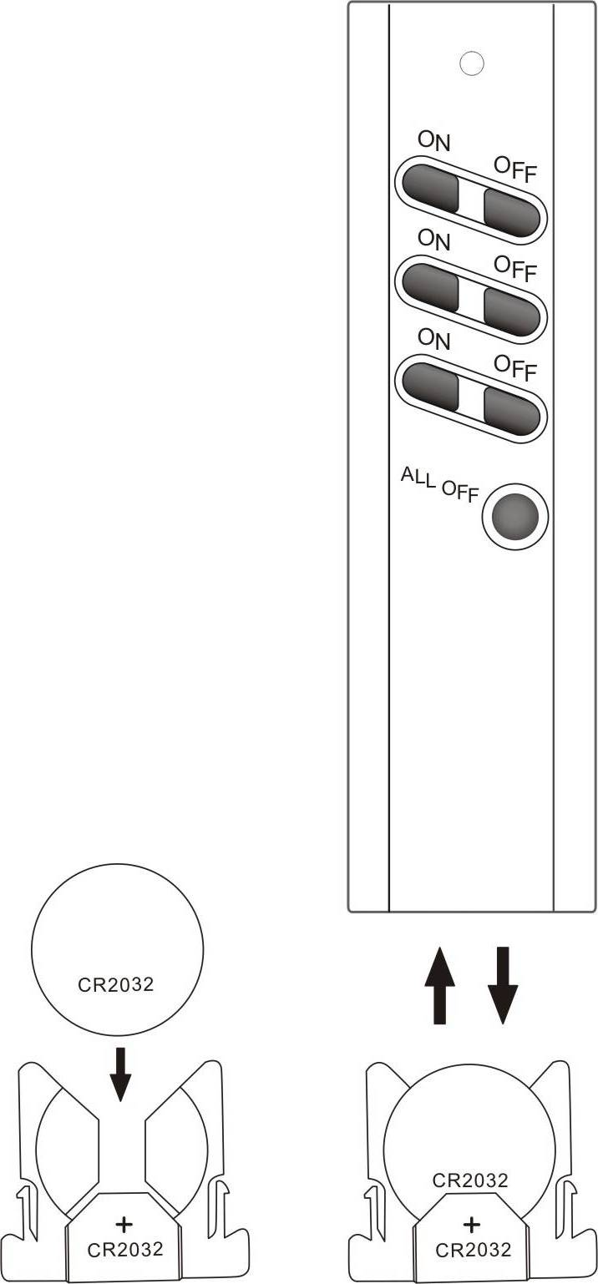

Troubleshoot:

Problem: The LED on remote control does not light up.

Solution: Please check if the battery is inserted correctly or replace a new battery.

Problem: I cannot pair my remote control with the receiver.
Solution: The memory on receiver is full, please delete one or more memory and try pairing again.

